#CountDown Timer  
  
#Importing Modules  
  
import tkinter as tk  
from datetime import datetime  
  
#Taking input from user  
  
seconds=int(input("Enter time in seconds for countdown:"))  
print('''A CountDown Timer Window is created in background.  
Minimize the tabs to use Countdown timer.^_^''')  
timer=66600+seconds  
run=False  
  
#Defing function for CountDown Timer  
  
def label_timer(label):  
  
 def running():  
  
   
 global timer  
 global run  
  
 if run:  
  
   
 if timer>=66600:  
  
   
 tt = datetime.fromtimestamp(timer)  
 string = tt.strftime("%H:%M:%S")  
 display=string  
  
   
 else:  
  
   
 display="Time Up.."  
 run=False   
  
 label['text']=display   
  
 label.after(1000, running)   
  
 timer -= 1   
  
 running()  
  
#Start Button function  
  
   
def Start(label):  
  
 global run   
  
 run=True  
   
 label_timer(label)  
   
 start['state']='disabled'  
  
 stop['state']='normal'  
  
 resume['state']='disabled'  
  
 reset['state']='normal'  
  
   
#Stop Button function  
  
   
def Stop(label):  
   
 global run   
  
 run=False  
  
 start['state']='disabled'  
  
 stop['state']='disabled'  
  
 resume['state']='normal'  
  
 reset['state']='normal'  
  
   
   
#Resume Button function  
  
  
def Resume(label):  
  
 global run   
  
 run=True  
  
 label_timer(label)  
  
 start['state']='disabled'  
  
 stop['state']='normal'  
  
 resume['state']='disabled'  
  
 reset['state']='normal'  
  
# Reset Button function   
  
  
def Reset(label):  
   
 global timer  
   
 timer=66600+seconds  
  
 tt1 = datetime.fromtimestamp(timer)  
   
 string1= tt1.strftime("%H:%M:%S")  
   
 display1=string1  
  
 label['text']=display1  
  
 global run   
  
 run=False  
  
 label_timer(label)  
  
 start['state']='normal'  
   
 stop['state']='disabled'  
  
 resume['state']='disabled'  
  
 reset['state']='disabled'  
  
  
  
#Title of the Window  
   
root = tk.Tk()  
  
root.title("Stopwatch")  
  
  
# Fixing the size of Window.   
  
  
root.minsize(width=650, height=300)   
  
label = tk.Label(root, text="CountDown..!", fg="red",bg="white", font="Verdana 30 bold")   
  
label.pack()   
  
f = tk.Frame(root)  
  
  
#Attributes of Buttons which are created inside Window  
  
  
start = tk.Button(f, text='Start', width=20, fg="red",bg="white" ,bd=10,  
 activeforeground="Orange",activebackground="white",  
 highlightcolor="purple",justify="right",padx=10,  
 pady=10,relief="groove",command=lambda:Start(label))   
  
stop = tk.Button(f, text='Stop/Pause',width=20,fg="red",bg="white" ,bd=10,  
 activeforeground="Orange",activebackground="white",  
 highlightcolor="purple",justify="right",padx=10,pady=10,  
 relief="groove",state='disabled', command=lambda:Stop(label))   
  
resume = tk.Button(f, text='Resume', width=20, fg="red",bg="white",bd=10,  
 activeforeground="Orange",activebackground="white",  
 highlightcolor="purple",justify="right",padx=10,pady=10,  
 relief="groove",state='disabled',  
 command=lambda:Resume(label) )  
  
reset = tk.Button(f, text='Reset',width=20, fg="red",bg="white",bd=10,  
 activeforeground="Orange",activebackground="white",  
 highlightcolor="purple",justify="right",padx=10,pady=10,  
 relief="groove",state='disabled',command=lambda:Reset(label))  
  
f.pack(anchor = 'center',pady=20)  
  
start.pack(side="left")   
  
stop.pack(side ="left")   
  
resume.pack(side="left")  
  
reset.pack(side="left")  
  
label1 = tk.Label(root, text="Timer",fg="white", bg="blue" ,  
 font="Verdana 30 bold")  
  
label1.pack()  
  
root.mainloop()

Output:

STEP-1:

**Giving input. So that countdown timer is set to given time (in seconds…).**

**After giving input as ‘Time in Seconds’, click “Enter” Button.**

STEP-2:

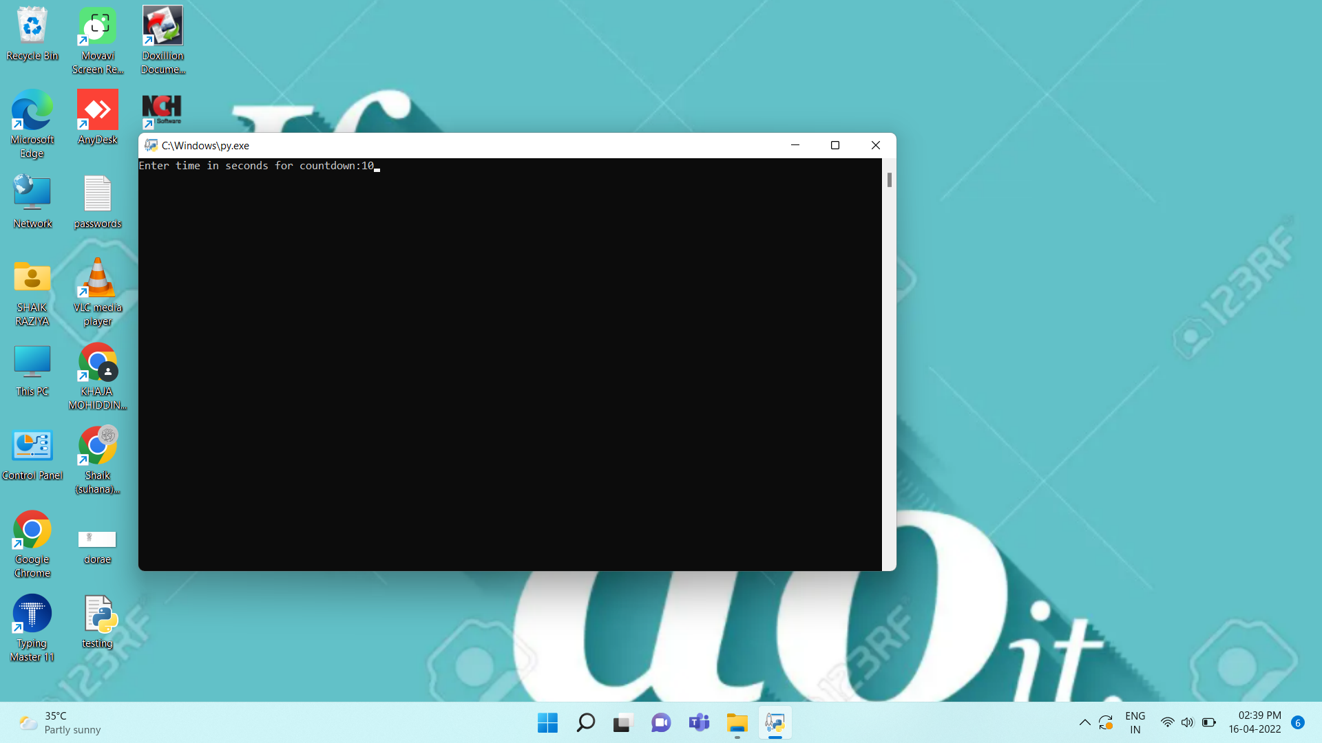

**A Countdown Timer window is created in background.**

***Note:*** If this window is not visible kindly close or minimize the tabs. Then you will find a window named ‘stopwatch’ which is our required **Countdown Timer** with features like

\***Start *Stop/Pause *Resume *Reset**

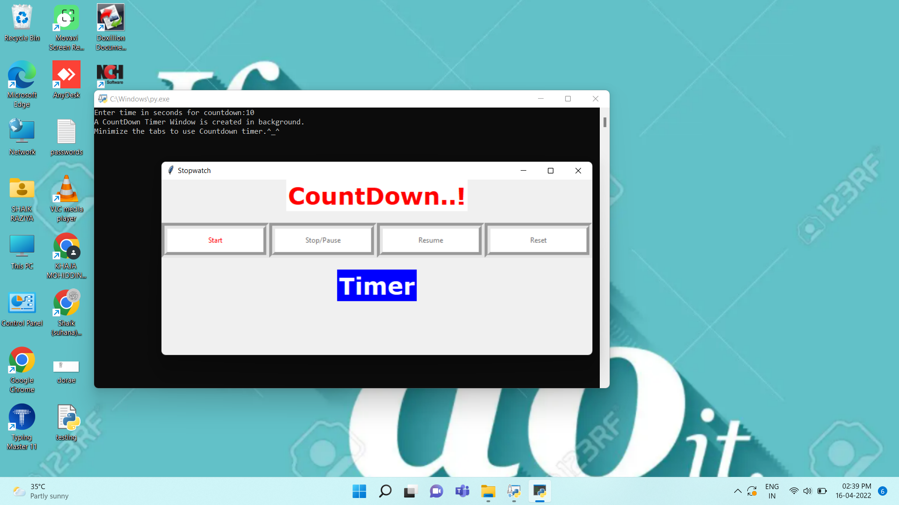

STEP-3:

**To start the Countdown Timer first click on Start button.**

**Now you can use any of the Buttons like Stop/Pause, Resume and Reset Buttons.**

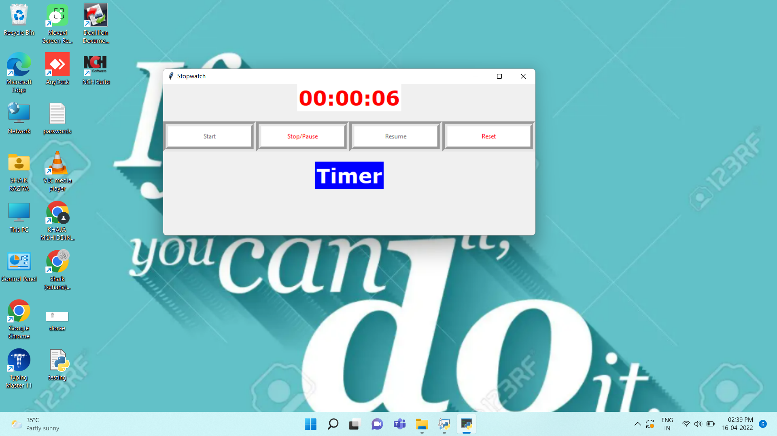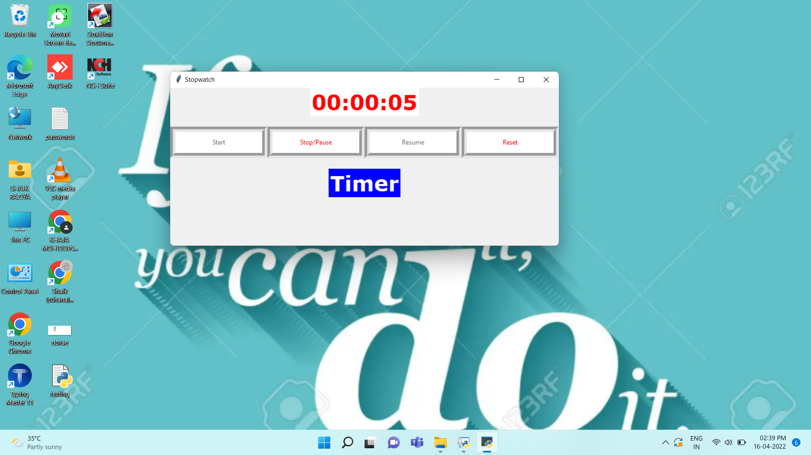

***At last, When countdown is finished {after reaching 0 seconds}***

**It displays Text “Time Up..”**

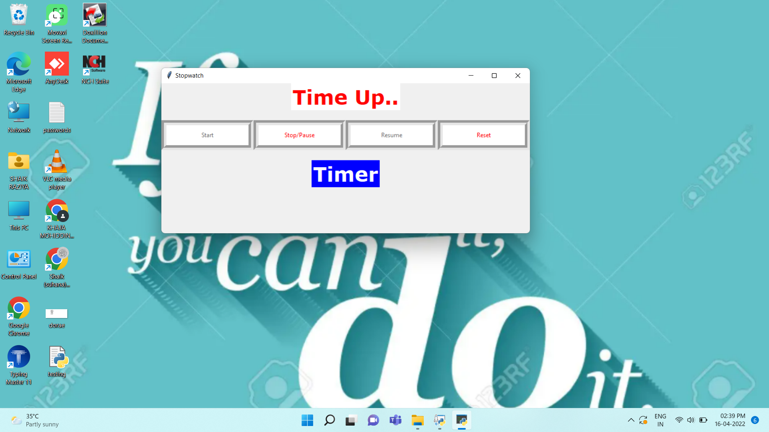

**If you want to countdown again you can simply click on Reset Button. The timer is again set to 10 seconds.**

**PROJECT SUBMITTED TO:** [**event@teachnook.com**](mailto:event@teachnook.com)

**PROJECT SUBMITTED By:**

SHAIK KHAJA MOHIDDIN.

**MOBILE NO:**

6303709931.

**EMAIL ID:**

shaikkhajamohiddin970@gmail.com